Project Design Phase-II
Data Flow Diagram & User Stories

Date | 01 NOV 2025
Team ID | NM2025TMID03572
Project Name | Laptop Request Catalog Item
Maximum Marks | 4 Marks

Data Flow Diagrams:
A Data Flow Diagram (DFD) visually represents how data moves within a system — showing inputs, processes, data storage, and outputs. It helps understand how user actions interact with system components and how information flows from one stage to another.In the project “Laptop Request Catalog Item”, the DFD shows how an employee submits a laptop request through the ServiceNow Service Catalog, how data is validated, and how the request flows to IT for approval and fulfillment. The system ensures correct form validations, dynamic visibility of fields, and proper routing to the IT fields, and proper routing to the IT team.
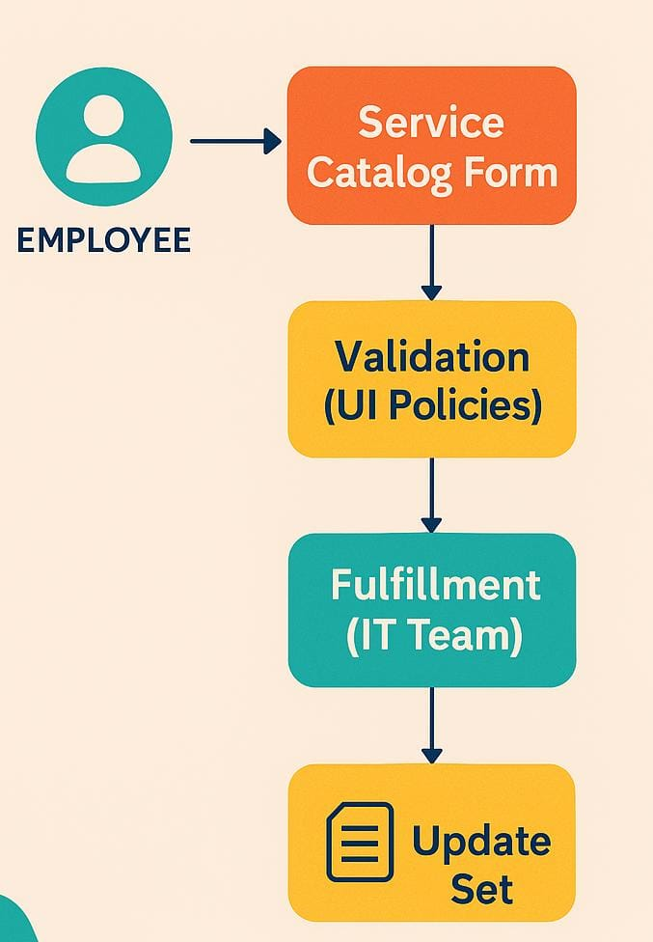
Example:

Flow

1. The Employee (User) opens the Laptop Request Catalog form and enters request details.
2. The System (ServiceNow) validates the input fields and applies UI policies (e.g., showing accessories details when required).
3. The UI Action (Reset Form) allows users to clear the form if needed.
4. The Request Data is sent to the Approval Workflow for review.
5. Once approved, the IT Fulfillment Team processes the request and allocates the laptop.
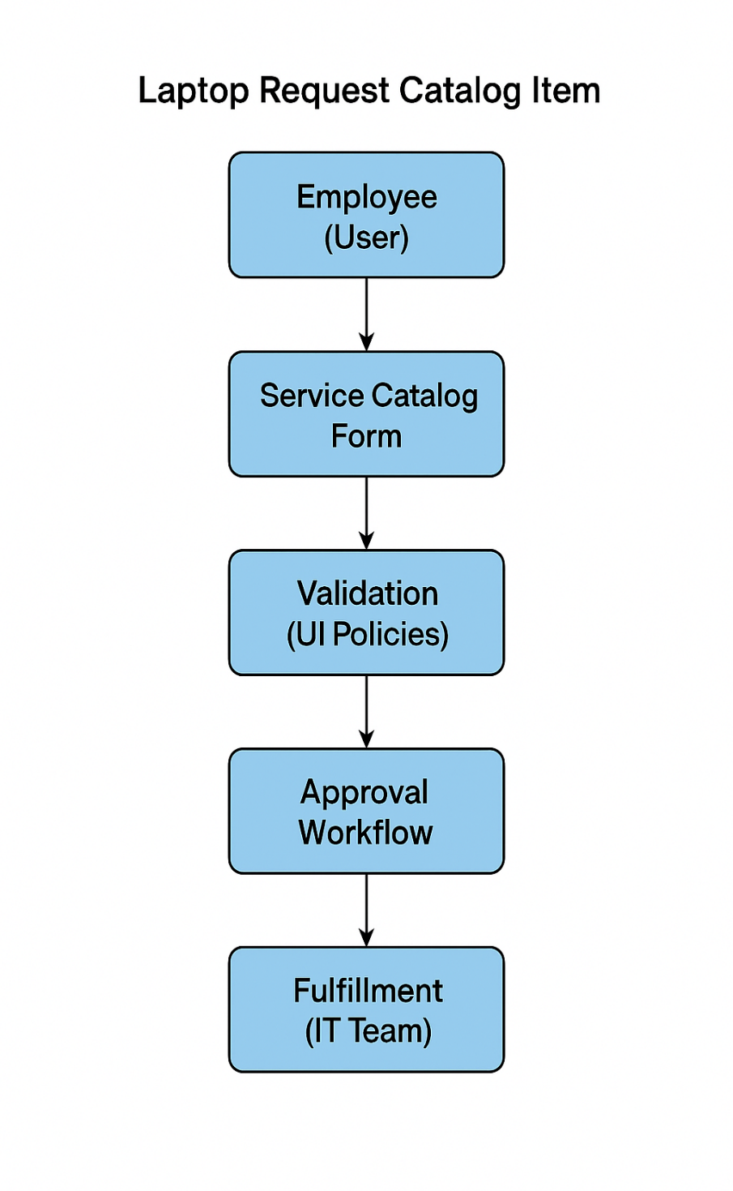

User Stories:
User stories define what different users need from the system in simple, goal-focused language. In this project, they help ensure the system blocks user deletion only when necessary, protecting incident data.

User Type | Functional  Requirement  (Epic) | User Story  Number | User Story / Task | Acceptance criteria | Priority | Release
Employee(Requester) | Submit Laptop Request | USN-1 |  | The request form collects correct data and submits successfully. | High | Sprint-1
  As an employee, I want to submit a laptop request through the Service Catalog so I can receive a new laptop easily.
System (Auto-validation) | Validate Form Fields | USN-2 | As a system, I must validate all required fields (Laptop Model, Justification) and show or hide “Accessories Details” based on selection. | The system dynamically shows and validates fields as per conditions. | High | Sprint-2
IT Admin(Approver) | Approve & Process Request | USN-3 |  | The approval workflow routes requests correctly and allows fulfillment. | Medium | Sprint-3
  As an IT admin, I want to review and approve the submitted laptop requests to ensure proper allocation.
Fulfillment Team | Deliver Laptop & Close Ticket | USN-4 | As a fulfillment team member, I want to assign and close the laptop request after delivery. | The request status changes to “Closed” after fulfilment. | Medium | Sprint-4

